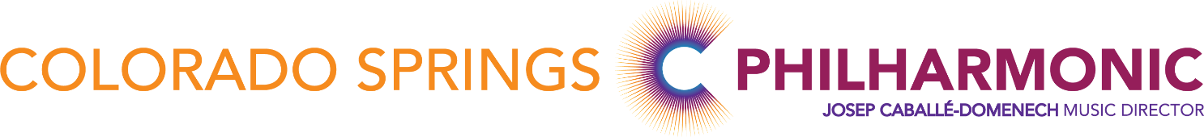

CSPO Percussion Audition Equipment 2022

Instruments Provided at the Audition:
Bass Drum – 36” on an Alan Abel rotating stand
Xylophone – Deagan 3 ½ octave no. 932 – very similar to the Musser M50
Orchestra Bells – Deagan no. 1590
Drumset – 5 Drums, Ride Cymbal, Crash Cymbal, and HighHat
Snare Drum – Hinger 14 x 6 ½, Renaissance batter head
Cymbals – 17” and 18” Sabian HHX pairs, 16” Zildjian K’s on Bass drum

>You may bring your own snare drum and cymbals, or you can use ours
>You must bring your own tambourine, triangle, and all sticks and mallets
>You will not be allowed to use plastic mallets on the xylophone. Hard rubber, or something similar to the Malletech/Bob Becker BB34’s are fine.

